Check if the following schedule is conflict serializable or not?

|  |  |
| --- | --- |
| T1 | T2 |
| read (A)  A : = A - 50 write(A)  read (B)  B : = B + 50  write (B) | read (A)  temp : = A • 0.1  A : = A – temp  write (A)  read (B)  B : = B + temp  write (B) |

Select one:

o No

o None o **Yes**

Does this graph have a deadlock?

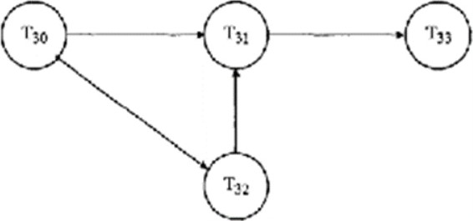

Select one:

o None

o YES

o **NO**

Before making any changes to the database, it is necessary to force-write all log records on the stable storage called

Select one:

o **WAL**

o WL

o None

o LLA

Which of the following concurrency control protocols ensure both conflict serializability and freedom from deadlock?

Select one:

o Multiple Granularity Protocol

o All

o 2-phase locking

o None

o **Time Stamp Ordering Protocol**

Reference: <https://byjus.com/question-answer/which-of-the-following-concurrency-control-protocols-ensure-both-conflict-serializability-and-freedom-from-deadlock/>

<https://testbook.com/question-answer/which-of-the-following-concurrency-control-protoco--60b62cdf0af08870b65c94aa>

A Database that is capable of integrating heterogeneous data from many sources and making links between datasets is database.

Select one:

o Wide column

o Document

o KeyValue Store

o **Graph**

Propagation of authorization from one user to another user leads to a tree termed as

Select one:

o None

o **Authorization**

o Authentication

o Both

Which prohibits the flow of information from higher to lower security level.

Select one:

o MAC and DAC

o None

o DAC

o **MAC**

Consider a join (relation algebra) between relations r(R)and s(S) using the nested loop method. There are 3 buffers each of size equal to disk block size, out of which one buffer is reserved for intermediate results. Assuming size(r(R)) < size(s(S)), the join will have fewer number of disk block accesses if

Select one:

o join selection factor between r(R) and s(S) is less than 0.5

o join selection factor between r(R) and s(S) is more than 0.5

o **relation r(R) is in the outer loop**

o relation s(S) is in the outer loop

Reference: <https://www.geeksforgeeks.org/gate-gate-cs-2014-set-2-question-40/>

The recovery manager ensures that the two important properties of transactions, namely,are preserved.

Select one:

o consistency and durability

o **atomicity and durability**

o atomicity and consistency

o Isolation and consistency

How many valid non serial schedules are possible for 5 transactions?

Select one:

o 120

o **37837680**

o 37837800

o 15

Reference: [(1+2+3+4+5)! / (1!.2!.3!.4!.5!)] – 5!

= 37837800 – 120

= 37837680